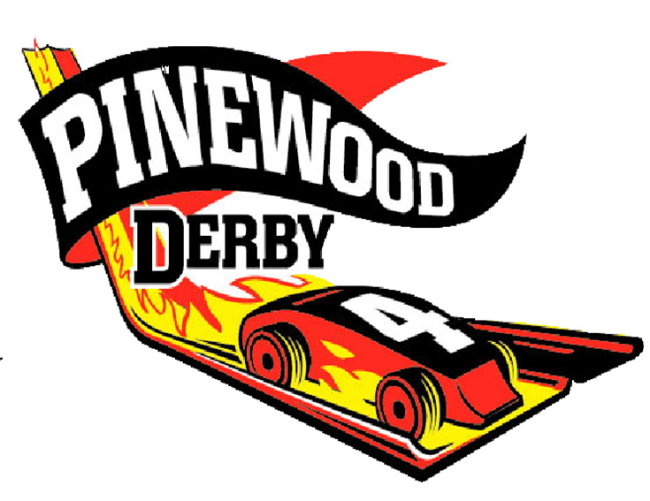

First Annual Pinewood Derby

Family Event – ALL AGES invited

Wednesday, March 25th

6:30-8pm (Gym)

Purchase car kits $4.00 from Children’s Ministry

& build your car at home.

Google for ideas and how to do this

(I have not done it – just sounds fun)

Can you help a child make a Car?

Call Me – Vicki 434-7392

First Annual Pinewood Derby

Family Event – All AGES invited

Wednesday, March 25th

6:30-8pm (Gym)

Purchase car kits $4.00 from Children’s Ministry

& build your car at home.

Google for ideas and how to do this

(I have not done it – just sounds fun)

Can you help a child make a Car?

Call Me – Vicki 434-7392

T-2. Weight: Race cars may weigh no more than five (5) ounces (total weight) as determined on the official scales during race day inspection.

T-3. Axles: The car must roll on the axles from an Official BSA Pinewood Derby kit. The wheels must be attached directly to the axle and spin freely. Use of the axle slots is not required. You may modify the axle shaft by sanding down the ridges that are at the head of an official BSA axel (for example).

T-4. Size: Race cars may be no longer than 7 inches, nor wider than 2 3/4 (2.75) inches, nor taller than 3 inches, as determined by the official gages during race day inspection. (Underside clearance of at least 3/8 (0.375) inches and inside wheel to wheel clearance of at least 1 3/4 (1.75) inches is recommended, so that the car will run on the racetrack. Adequate clearance is the responsibility of the race car builder.)

T-5. Weights and Attachment: Weight may be added to the car and will be considered part of the car for purposes of all measurements. "Weight" is considered to be any material on the car that is not provided in the kit. All weight must be securely fastened to the car, e.g. by permanent glue, nails or screws, Weights shall be passive, i.e. non-moveable, nonmagnetic, non-electric, non-sticky, etc.

T-6. Wheels: There must be at least four wheels on the car, however, it is not required that all four wheels make contact with the track. You may paint or polish any part of the wheel. All of the original "tread marks" on the wheel face must be intact. It must be apparent to the inspector that the tread marks are intact (*). Wheel treads must remain flat (*). The inner step at the wheel hub must also remain intact, it cannot be removed (*). The words "Official B.S.A." and other lettering on the wheels (inside and outside) shall remain intact and clearly visible to the inspector. No additional items may be added to the wheels or axles such as washers, springs, bearings, sleeves, bushings, O-rings, etc. *(see Picture’s on Page 6 for example)

T-7. Gravity Powered: The race car may not be constructed or treated in such a way that the track's starting mechanism imparts momentum to the car. (For instance, this provision disqualifies cars with sticky substances on the front of the car and protrusions which may catch on the starting pin.)

T-8. Lubricants: Graphite lubrication is common. Other lubricants are allowed. ALL lubricants cannot leak or foul the track. ALL excess MUST be removed. All lubricants must be dry at the time of inspection/racing and NOT applied to the exterior of the wheels.

T-9. Staging: The car nose must not be pointed or forked. No part of the car can protrude past the starting pin. T-10. Body: The car body may have no moving parts.

T-2. Weight: Race cars may weigh no more than five (5) ounces (total weight) as determined on the official scales during race day inspection.

T-3. Axles: The car must roll on the axles from an Official BSA Pinewood Derby kit. The wheels must be attached directly to the axle and spin freely. Use of the axle slots is not required. You may modify the axle shaft by sanding down the ridges that are at the head of an official BSA axel (for example).

T-4. Size: Race cars may be no longer than 7 inches, nor wider than 2 3/4 (2.75) inches, nor taller than 3 inches, as determined by the official gages during race day inspection. (Underside clearance of at least 3/8 (0.375) inches and inside wheel to wheel clearance of at least 1 3/4 (1.75) inches is recommended, so that the car will run on the racetrack. Adequate clearance is the responsibility of the race car builder.)

T-5. Weights and Attachment: Weight may be added to the car and will be considered part of the car for purposes of all measurements. "Weight" is considered to be any material on the car that is not provided in the kit. All weight must be securely fastened to the car, e.g. by permanent glue, nails or screws, Weights shall be passive, i.e. non-moveable, nonmagnetic, non-electric, non-sticky, etc.

T-6. Wheels: There must be at least four wheels on the car, however, it is not required that all four wheels make contact with the track. You may paint or polish any part of the wheel. All of the original "tread marks" on the wheel face must be intact. It must be apparent to the inspector that the tread marks are intact (*). Wheel treads must remain flat (*). The inner step at the wheel hub must also remain intact, it cannot be removed (*). The words "Official B.S.A." and other lettering on the wheels (inside and outside) shall remain intact and clearly visible to the inspector. No additional items may be added to the wheels or axles such as washers, springs, bearings, sleeves, bushings, O-rings, etc. *(see Picture’s on Page 6 for example)

T-7. Gravity Powered: The race car may not be constructed or treated in such a way that the track's starting mechanism imparts momentum to the car. (For instance, this provision disqualifies cars with sticky substances on the front of the car and protrusions which may catch on the starting pin.)

T-8. Lubricants: Graphite lubrication is common. Other lubricants are allowed. ALL lubricants cannot leak or foul the track. ALL excess MUST be removed. All lubricants must be dry at the time of inspection/racing and NOT applied to the exterior of the wheels.

T-9. Staging: The car nose must not be pointed or forked. No part of the car can protrude past the starting pin. T-10. Body: The car body may have no moving parts.

